**NUXT PINIA**

We will be using Yarn instead of Npm, as it is a little tricker to get Pinia with Nuxt with npm. We can try with Npm as well, but now we will use yarn.

To install Yarn run the following command

npm install --global yarn

now create a Nuxt app.

npx nuxi@latest init <YOUR-APP-NAME>

now type following in cmd

yarn install

now in project directory create a folder named pages

now create a file in pages directory called index.vue, the pages/index.vue file will be our home page now. Also delete the app.vue in root directory.

Create a new file pages/cart. Vue, where you will add all the items in a basket selected by user.

Create a new folder in root directory called layouts. And create a file layout/default.vue. in this file we will create a default layout of the website.

Now type the following code inside default.vue file

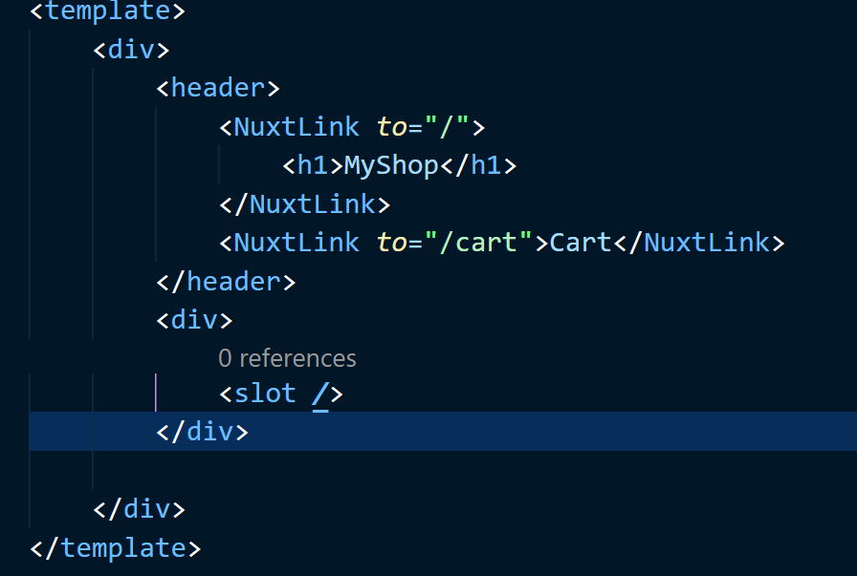

NOW, type yarn dev in cmd.

**Adding Google Material Icons**

Go to google material icons website

<https://fonts.google.com/icons?selected=Material+Symbols+Outlined:shopping_bag:FILL@0;wght@400;GRAD@0;opsz@48&icon.query=cart>

to add Material icons to Nuxt project.

Go to nuxt.config.ts file

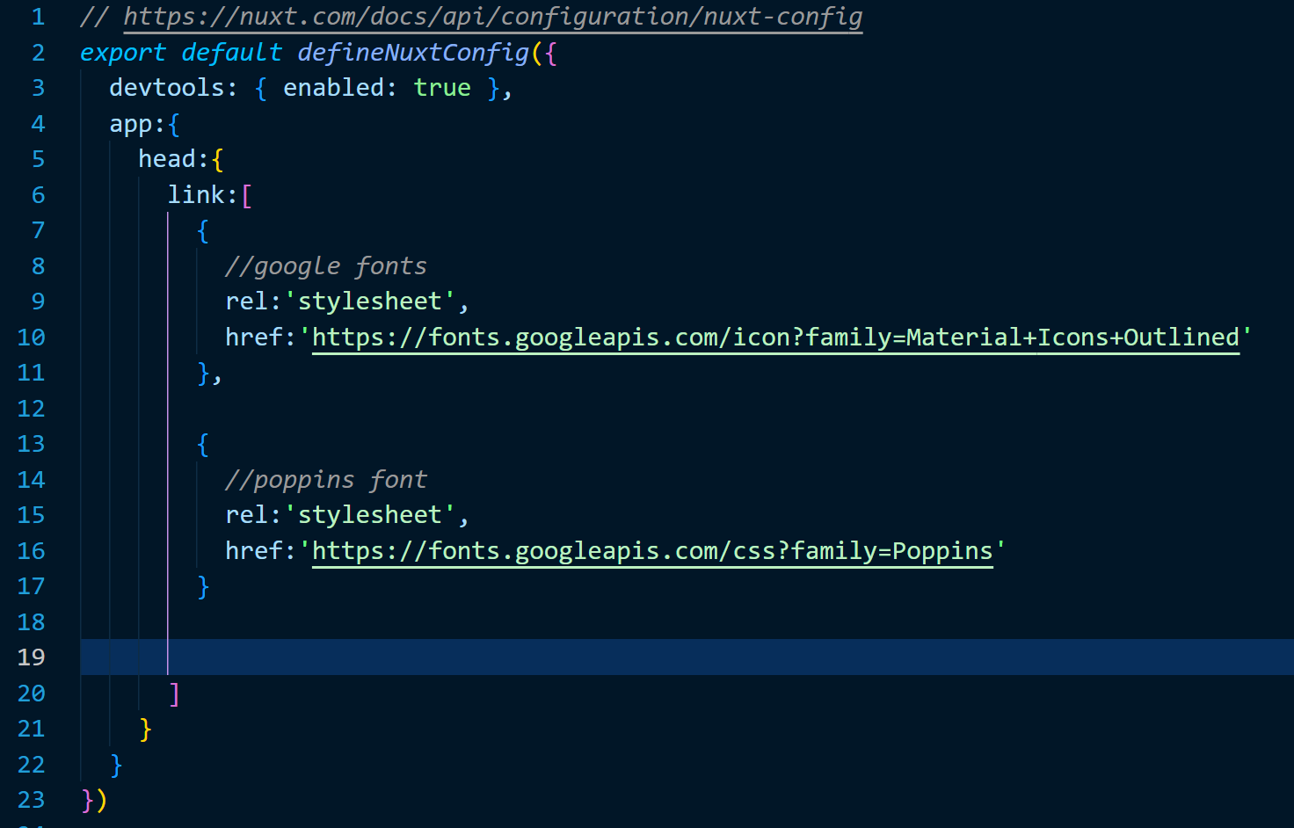

Now go to layout/default.vue file and add google fonts in template

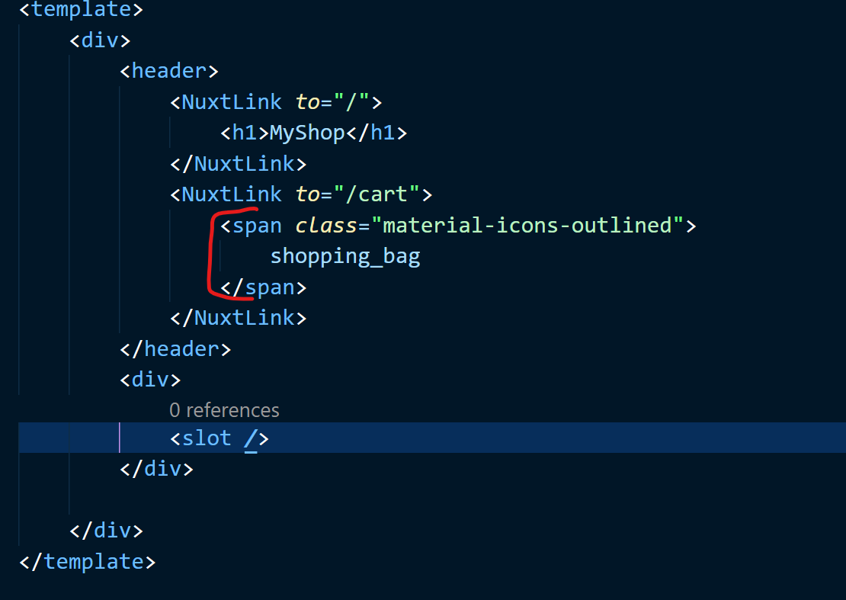

**Adding Tailwind CSS**

To extend tailwind CSS we create a new folder in root directory called assets, and create a folder inside it called CSS, and inside assets/CSS folder create a file called tailwind.css. the module will automatically look for this file (assets/CSS/tailwind.css) and apply any additional classes or styles that we implement in assets/CSS/tailwind.css file

To get Tailwind CSS in Nuxt application run the following command inside cmd

yarn add -D @nuxtjs/tailwindcss

now in assets/CSS/tailwind.css file copy and paste the following.

@tailwind base;

@tailwind components;

@tailwind utilities;

and after that go to nuxt.config.ts file and register tailwind CSS as a module.

To register the module, we go to package. Json file and find the nuxt/tailwind module, copy it and paste it in nuxt.config.ts ->modules

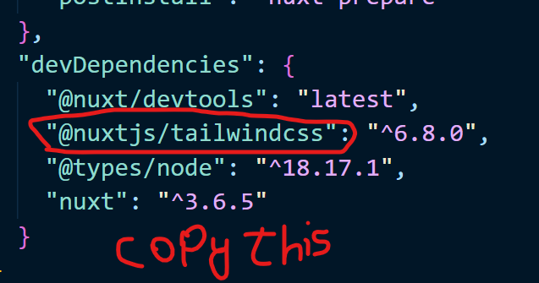

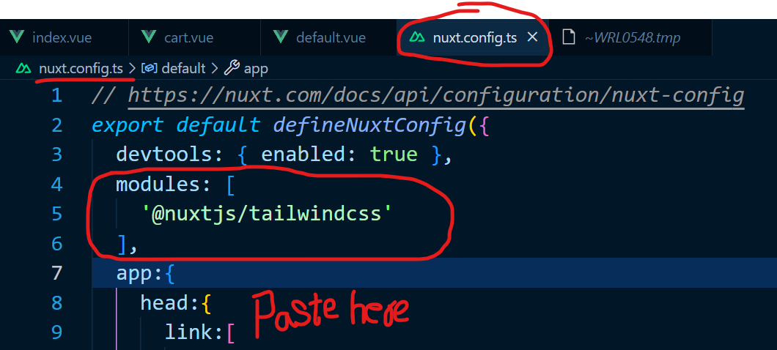

Now the module is registered. 👍

Now, we need tailwind.config.js file in our project, in tailwind.config.js file we can do things like extend the theme, add new colours and fonts etc. to get this file we type the following command in cmd

npx tailwindcss init

Now in tailwind.config.js file, we want to extend the theme, so we write the following code:

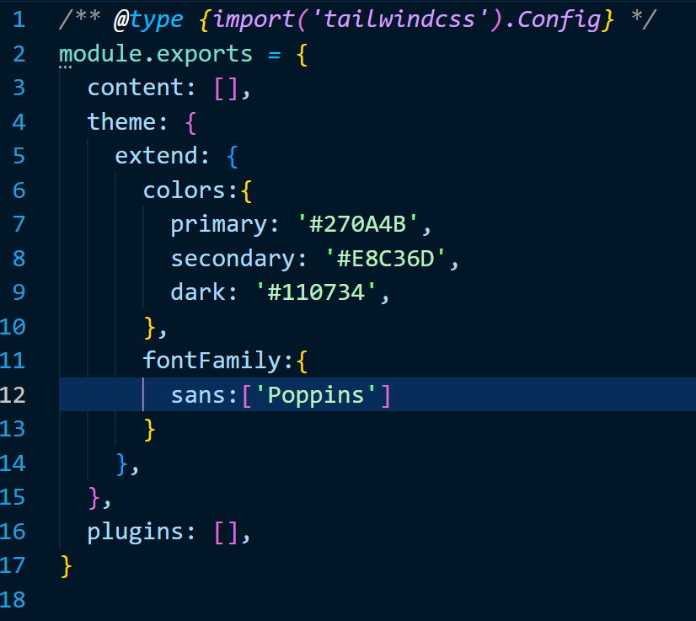

Now we can go to our layouts/default.vue file and make use of some tailwind classes made in tailwind.config.js file (primary, secondary and dark colour classes)

**Adding Pinia**

Type the following command to add pinia to Nuxt application

**yarn add pinia @pinia/nuxt**

now, add Pinia to modules in your nuxt.config.js file

**export default defineNuxtConfig({**

**// ... other options**

**modules: [**

**// ...**

**'@pinia/nuxt',**

**],**

**})**

**Adding form kit**

[**https://nuxt.com/modules/formkit**](https://nuxt.com/modules/formkit)

use the following command to get form kit

**yarn add @formkit/nuxt**